MPP SYSTEM Assessment Tools (PowerShell Scripts)

**Instructions – Steps to Run the PowerShell Programs**

**Step1:** Create local folders with the following locations:

* C:\APS2SQLDW\0_PreAssessment
* C:\APS2SQLDW\Output\0_PreAssessment

**Step 2:** Copy Following files into the directory C:\APS2SQLDW\0_PreAssessment:

* PreAssessmentDriver.ps1
* RunSQLStatementExportCSV.ps1
* CopyDataToExcel.ps1
* SQLScriptstoRun.csv

Note: You need to open the SQLScriptstoRun.csv file, replace the IP address with your own MPP server IP address in the cell F8, F9, and F10. Look for this line of code that contains the following information, replace <10.###.222.###> with your own MPP IP Address:

Declare @ServerName varchar(50)= '10.###.222.###'

**Step 3:** Run PowerShell Script: PreAssessmentDriver.ps1

The scripts will prompt you for the following information:

**“Enter the name of the SQLScriptToRun.csv File.”** – This will be the location\name of the config File SQLScriptToRun.csv. (Default: C:\APS2SQLDW\0_PreAssessment\SQLScriptToRun.csv)

**“Enter the Path of the Output File Directory.”** – This will be the location all result/output files are stored. (Default: C:\APSPreAssessment\Output\0_PreAssessment)

**“Enter the name of the Server”** - This is the APS server you want to connect to: “aps,17001” or “APS Server IP Address, 17001”

**“Enter ‘Yes’ to connect using Integrated security, otherwise Enter 'No'”**

Answer YES or No. If the answer is No, the program will prompt you for additional information:

**“Enter the User Name if not using Integrated:”** – User name with permission run the scripts

**“PDW Password”** – Enter the Password for the user – reads password as a secure string

You may need to grant permission to these PowerShell scripts:

Unblock-File -Path C:\APS2SQLDW\0_PreAssessment\PreassessmentDriver.ps1

Unblock-File -Path C:\APS2SQLDW\0_PreAssessment\RunSQLStatementExportCSV.ps1

Unblock-File -Path C:\APS2SQLDW\0_PreAssessment\CopyDataToExcel.ps1

**Step 4: Run PowerShell Script:** CopyDataToExcel.ps1

Prerequisite: **Install-Module ImportExcel**  (Run the command from a PS command prompt. Command Prompt must be running as admin)

This PowerShell script will prompt for the following information:

**“Enter the Path to the Pre-Assessment output files.”** – This will be the location\name of the pre-Assessment output. (Default: C:\APS2SQLDW\output\0_PreAssessment)

**“Enter the Path to save excel file.”** (Default: C:\APS2SQLDW\output\0_PreAssessment)

**“Enter the name of the Excel File”** (Default: Pre-Assessment.xlsx)

**Step 5: Collect the output files**

Examine and collect the output files. If you followed the instructions closely, you will see the following output files appear in this folder: C:\APS2SQLDW\Output\0_PreAssessment

Below is a list of samples output files:

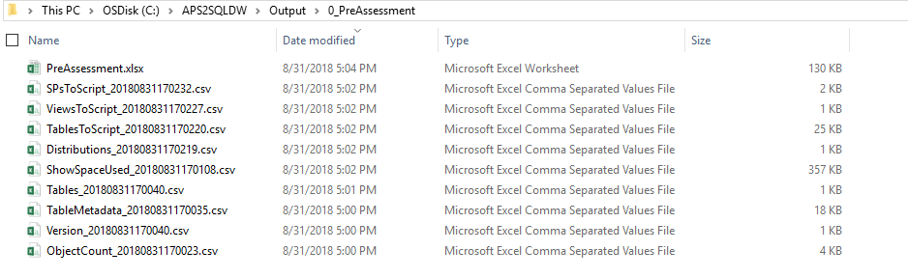

If you run into problems or need assistance, please reach out to Gail Zhou at [gazho@microsoft.com](mailto:gazho@microsoft.com) or Andy Isley at [charis@microsoft.com](mailto:charis@microsoft.com).